PRINCIPLES OF DATA SCIENCE
HARISHKUMAR ID 241801086
EXP2 :DATA DISCOVERY & PREPARATION
Learning Objectives
The objective of this experiment is to understand the process of data discovery and preparation by exploring a customer churn dataset. It aims to learn how to clean and preprocess data, perform distribution and relationship analysis, detect outliers, prepare the dataset using train-test splitting, and save the processed data for machine learning applications.

Libraries Used
This experiment uses the Pandas library for data manipulation and preprocessing, Matplotlib and Seaborn for creating statistical visualizations, LabelEncoder to convert categorical variables into numerical values, StandardScaler to standardize numerical features, and train_test_split from Scikit-learn to divide the dataset into training and testing sets.

coding

import pandas as pd import matplotlib.pyplot as plt import seaborn as sns

from sklearn.preprocessing import LabelEncoder, StandardScaler from sklearn.model_selection import train_test_split

df = pd.read_csv("C:\\Users\\Shyam
Ganesh\\Downloads\\archive\\customer_churn_dataset-testing-master.csv")

print("First 10 Records") print(df.head(10)) print("\nLast 10 Records") print(df.tail(10))

print("\nShape") print(df.shape)

print("\nColumns") print(df.columns)

print("\nDataset Info") print(df.info())

print("\nSummary") print(df.describe())

print("\nMissing Values") print(df.isnull().sum())

print("\nDuplicate Records") print(df.duplicated().sum())

# ------------------------------------------
# Step 4 : Data Cleaning
# ------------------------------------------

# Remove duplicates df.drop_duplicates(inplace=True)

# Fill missing values for col in df.columns:

if df[col].dtype == "object":
df[col] = df[col].fillna(df[col].mode()[0])

else:
df[col] = df[col].fillna(df[col].median())

print("\nMissing Values After Cleaning") print(df.isnull().sum())

# ------------------------------------------ # Step 5 : Encode Categorical Columns
# ------------------------------------------

encoder = LabelEncoder()

categorical = [ "Gender",
"Subscription Type",
"Contract Length",
"Churn"
]

for col in categorical:

if col in df.columns:
df[col] = encoder.fit_transform(df[col])

scaler = StandardScaler()

num_cols = [
"Age",
"Tenure",
"Usage Frequency",
"Support Calls",
"Payment Delay",
"Total Spend",
"Last Interaction"
]

df[num_cols] = scaler.fit_transform(df[num_cols])

# ------------------------------------------
# Step 7 : Correlation Heatmap
# ------------------------------------------

plt.figure(figsize=(10,8))

sns.heatmap(df.corr(numeric_only=True),
annot=True, cmap="coolwarm") plt.title("Correlation Heatmap")

plt.show()

# ==========================================
# Task 2
# Distribution Analysis
# ==========================================

cols = [
"Churn",
"Gender",
"Contract Length",
"Subscription Type"
]

for col in cols:

plt.figure(figsize=(6,4))

sns.countplot(x=df[col])

plt.title(col)

plt.show()

# ========================================== # Task 3
# Histogram & Boxplot
# ==========================================

plot_cols = [
"Age",
"Tenure",
"Total Spend"
]

for col in plot_cols:

plt.figure(figsize=(6,4))

sns.histplot(df[col], kde=True)

plt.title("Histogram of " + col)

plt.show()

plt.figure(figsize=(6,4))

sns.boxplot(x=df[col])

plt.title("Boxplot of " + col)

plt.show()
# ==========================================
# Task 4
# Outlier Detection using IQR
# ==========================================

print("\nOutliers using IQR")

for col in num_cols:

Q1 = df[col].quantile(0.25)

Q3 = df[col].quantile(0.75)

IQR = Q3 - Q1

lower = Q1 - 1.5 * IQR

upper = Q3 + 1.5 * IQR

outliers = df[(df[col] < lower) | (df[col] > upper)]

print(col, ":", len(outliers))

# ==========================================
# Task 5
# Relationship Analysis
# ========================================== plt.figure(figsize=(6,4)) sns.countplot(x="Contract Length", hue="Churn", data=df) plt.title("Contract Length vs Churn") plt.show()

plt.figure(figsize=(6,4)) sns.countplot(x="Subscription Type", hue="Churn", data=df) plt.title("Subscription Type vs Churn") plt.show()

plt.figure(figsize=(6,4)) sns.boxplot(x="Churn", y="Total Spend", data=df) plt.title("Total Spend vs Churn") plt.show()

plt.figure(figsize=(6,4)) sns.boxplot(x="Churn", y="Tenure", data=df) plt.title("Tenure vs Churn") plt.show()

# Scatter Plot

plt.figure(figsize=(6,4)) sns.scatterplot(x="Tenure",
y="Total Spend", hue="Churn", data=df) plt.title("Tenure vs Total Spend")

plt.show()

# ==========================================
# Task 6
# Analytical Questions
# ==========================================

print("\nContract Length with Highest Churn")

print(df.groupby("Contract Length")["Churn"].mean())

print("\nSubscription Type with Highest Churn")

print(df.groupby("Subscription Type")["Churn"].mean())

print("\nAverage Tenure by Churn")

print(df.groupby("Churn")["Tenure"].mean())

print("\nAverage Total Spend by Churn")

print(df.groupby("Churn")["Total Spend"].mean())

print("\nCorrelation with Churn")

print(df.corr(numeric_only=True)["Churn"].sort_values(ascending=False)) # ==========================================
# Task 7
# Train Test Split
# ==========================================

X = df.drop("Churn", axis=1)

y = df["Churn"]

X_train, X_test, y_train, y_test = train_test_split(
X, y,
test_size=0.20, random_state=42
)

print("\nTraining Data Shape :", X_train.shape)

print("Testing Data Shape :", X_test.shape)

# ==========================================
# Task 8
# Save Processed Dataset
# ==========================================

df.to_csv("CustomerChurn_Preprocessed.csv", index=False) print("\nDataset Saved Successfully!")

print("\nFile Name : CustomerChurn_Preprocessed.csv") OUTPUT:
First 10 Records
CustomerID Age Gender Tenure Usage Frequency Support Calls \
- 1 22 Female 25 14 4
- 2 41 Female 28 28 7
- 3 47 Male 27 10 2
- 4 35 Male 9 12 5
- 5 53 Female 58 24 9
- 6 30 Male 41 14 10
- 7 47 Female 37 15 9
- 8 54 Female 36 11 0
- 9 36 Male 20 5 10
- 10 65 Male 8 4 2

Payment Delay Subscription Type Contract Length Total Spend \
- 27 Basic Monthly 598
- 13 Standard Monthly 584
- 29 Premium Annual 757
- 17 Premium Quarterly 232
- 2 Standard Annual 533
- 10 Premium Monthly 500
- 28 Basic Quarterly 574
- 18 Standard Monthly 323
- 8 Basic Monthly 687
- 23 Basic Annual 995

Last Interaction Churn
- 9 1
- 20 0
- 21 0
- 18 0
- 18 0
- 29 0
- 14 1
- 16 0
- 8 0
- 10 0

Last 10 Records
CustomerID Age Gender Tenure Usage Frequency Support Calls \
- 64365 48 Female 36 22 4
- 64366 26 Female 54 24 2
- 64367 64 Male 30 27 9
- 64368 51 Male 47 17 10
- 64369 45 Male 3 1 5
- 64370 45 Female 33 12 6
- 64371 37 Male 6 1 5
- 64372 25 Male 39 14 8
- 64373 50 Female 18 19 7
- 64374 52 Female 45 15 9

Payment Delay Subscription Type Contract Length Total Spend \
- 22 Premium Annual 342
- 21 Basic Annual 165
- 28 Premium Annual 884
- 26 Basic Annual 544
- 11 Standard Annual 218
- 21 Basic Quarterly 947
- 22 Standard Annual 923
- 30 Premium Monthly 327
- 22 Standard Monthly 540
- 25 Standard Monthly 696

Last Interaction Churn
- 9 1
- 23 1
- 21 1
- 24 1
- 15 1
- 14 1
- 9 1
- 20 1
- 13 1
- 22 1

Shape
(64374, 12)

Columns
Index(['CustomerID', 'Age', 'Gender', 'Tenure', 'Usage Frequency',
'Support Calls', 'Payment Delay', 'Subscription Type', 'Contract Length', 'Total Spend', 'Last Interaction', 'Churn'], dtype='object')

Dataset Info
<class 'pandas.core.frame.DataFrame'>
RangeIndex: 64374 entries, 0 to 64373 Data columns (total 12 columns):
# Column Non-Null Count Dtype
--- ------ -------------- -----
- CustomerID 64374 non-null int64
- Age 64374 non-null int64
- Gender 64374 non-null object
- Tenure 64374 non-null int64
- Usage Frequency 64374 non-null int64
- Support Calls 64374 non-null int64
- Payment Delay 64374 non-null int64
- Subscription Type 64374 non-null object
- Contract Length 64374 non-null object
- Total Spend 64374 non-null int64
- Last Interaction 64374 non-null int64 11 Churn 64374 non-null int64 dtypes: int64(9), object(3) memory usage: 5.9+ MB
None

Summary
CustomerID Age Tenure Usage Frequency \ count 64374.000000 64374.000000 64374.000000 64374.000000 mean 32187.500000 41.970982 31.994827 15.080234 std 18583.317451 13.924911 17.098234 8.816470 min 1.000000 18.000000 1.000000 1.000000
25% 16094.250000 30.000000 18.000000 7.000000
50% 32187.500000 42.000000 33.000000 15.000000 75% 48280.750000 54.000000 47.000000 23.000000 max 64374.000000 65.000000 60.000000 30.000000

Support Calls Payment Delay Total Spend Last Interaction \ count 64374.000000 64374.000000 64374.000000 64374.000000 mean 5.400690 17.133952 541.023379 15.498850 std 3.114005 8.852211 260.874809 8.638436 min 0.000000 0.000000 100.000000 1.000000
25% 3.000000 10.000000 313.000000 8.000000
50% 6.000000 19.000000 534.000000 15.000000 75% 8.000000 25.000000 768.000000 23.000000 max 10.000000 30.000000 1000.000000 30.000000

Churn
count 64374.000000 mean 0.473685 std 0.499311 min 0.000000
25% 0.000000
50% 0.000000 75% 1.000000 max 1.000000 Missing Values
CustomerID 0
Age 0
Gender 0
Tenure 0
Usage Frequency 0
Support Calls 0
Payment Delay 0
Subscription Type 0
Contract Length 0
Total Spend 0
Last Interaction 0
Churn 0
dtype: int64

Duplicate Records
0

Missing Values After Cleaning
CustomerID 0
Age 0
Gender 0
Tenure 0
Usage Frequency 0
Support Calls 0
Payment Delay 0
Subscription Type 0
Contract Length 0
Total Spend 0
Last Interaction 0
Churn 0
dtype: int64
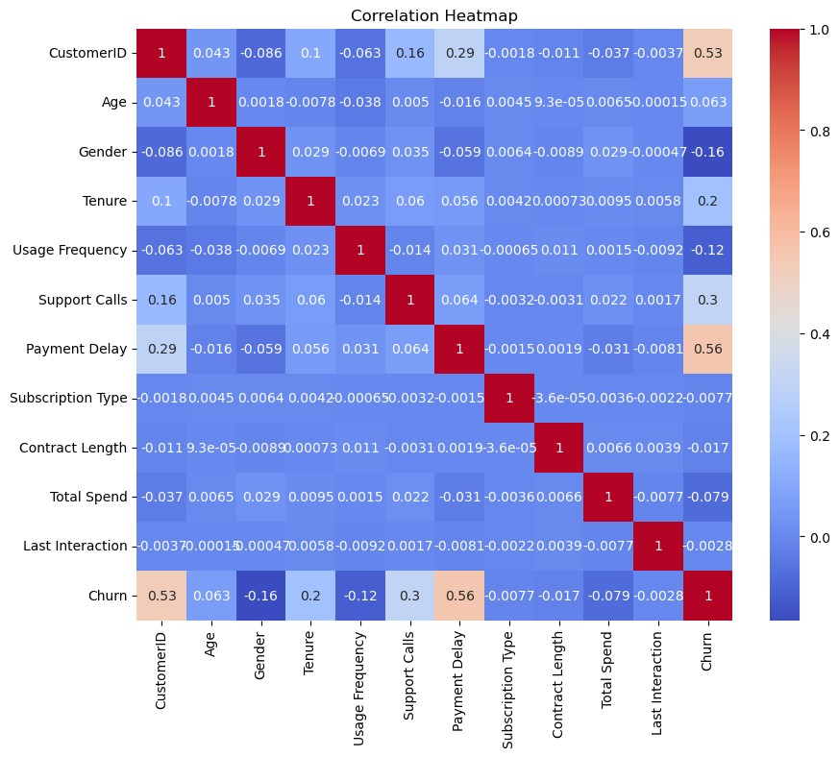
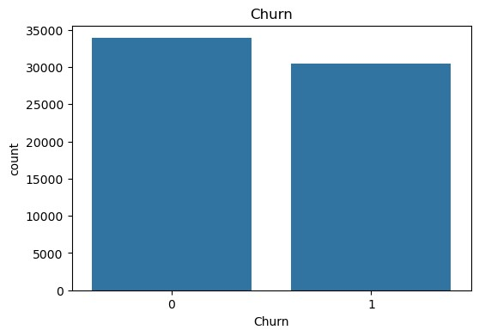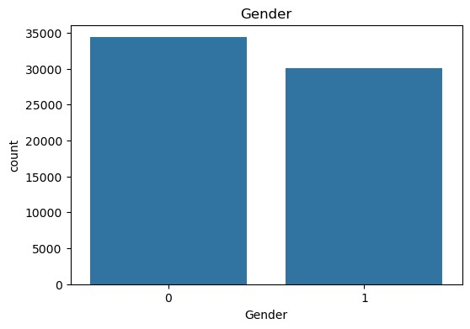
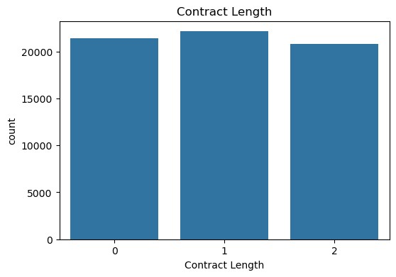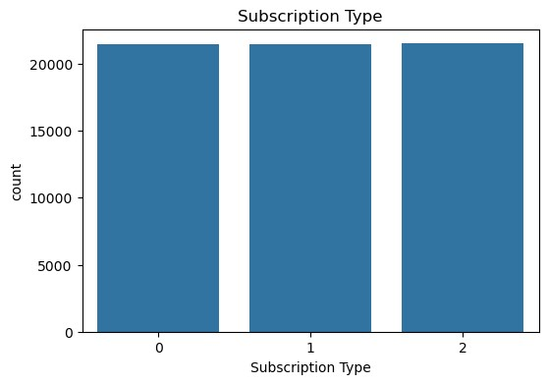
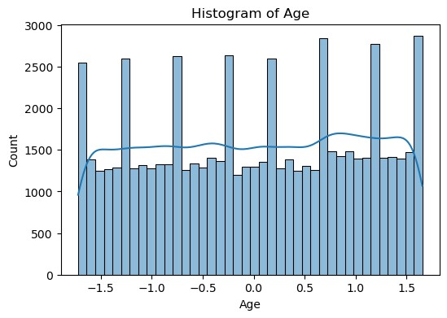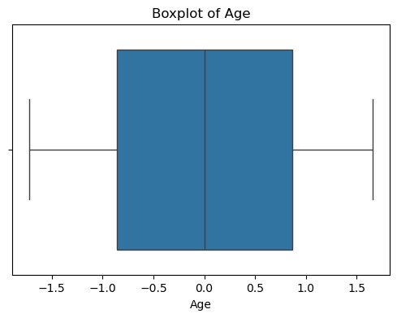
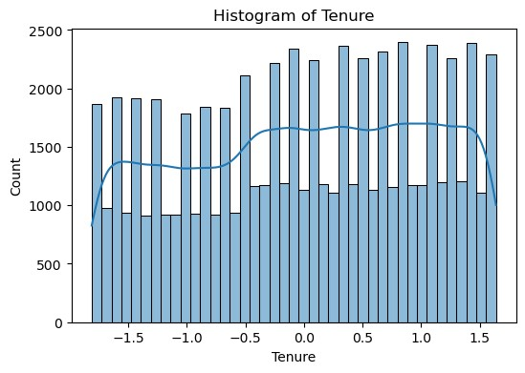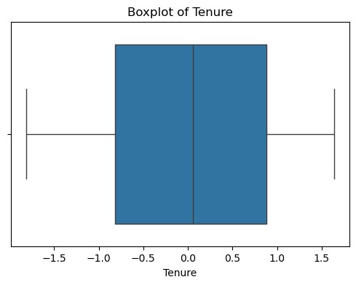
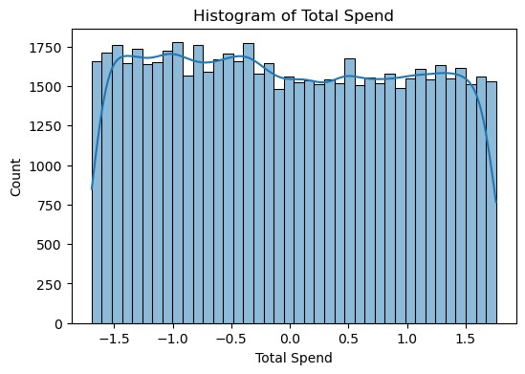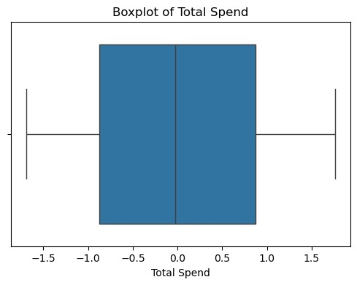

Outliers using IQR
Age : 0
Tenure : 0
Usage Frequency : 0
Support Calls : 0
Payment Delay : 0
Total Spend : 0
Last Interaction : 0
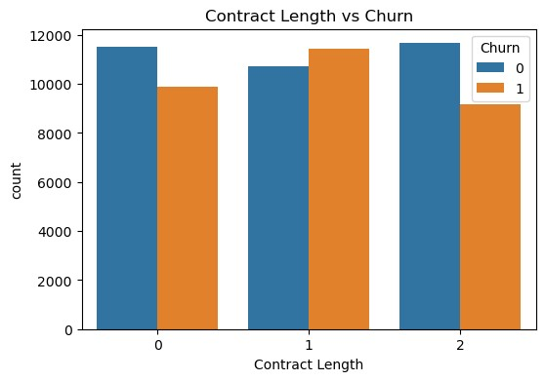
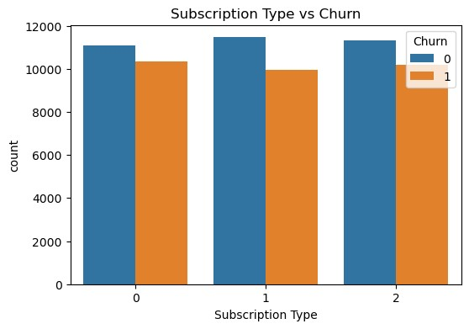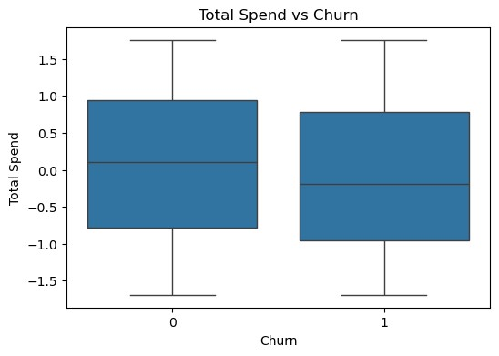

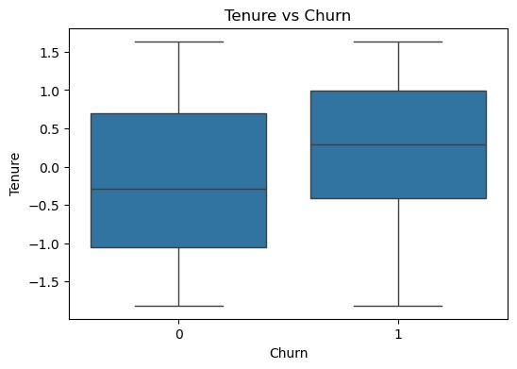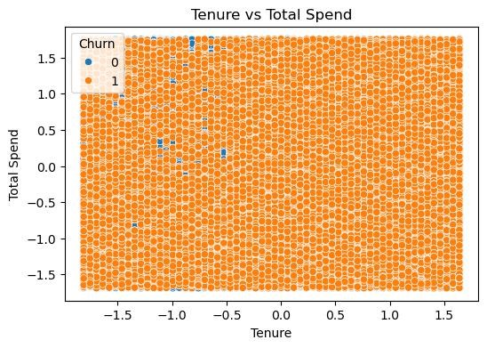

Contract Length with Highest Churn
Contract Length
- 0.462167
- 0.516087
- 0.440482
Name: Churn, dtype: float64

Subscription Type with Highest Churn
Subscription Type
- 0.482775
- 0.464964
- 0.473305
Name: Churn, dtype: float64

Average Tenure by Churn
Churn
- -0.185304
- 0.205893
Name: Tenure, dtype: float64

Average Total Spend by Churn
Churn
- 0.074820
- -0.083133
Name: Total Spend, dtype: float64

Correlation with Churn
Churn 1.000000
Payment Delay 0.557386
CustomerID 0.529832 Support Calls 0.304631 Tenure 0.195327
Age 0.063457
Last Interaction -0.002818
Subscription Type -0.007738
Contract Length -0.017098
Total Spend -0.078867
Usage Frequency -0.115098
Gender -0.164549
Name: Churn, dtype: float64

Training Data Shape : (51499, 11)
Testing Data Shape : (12875, 11)

Dataset Saved Successfully!

File Name : CustomerChurn_Preprocessed.csv

Learning Outcomes
After completing this experiment, students will be able to explore and preprocess datasets, handle missing values and duplicate records, encode categorical features, standardize numerical data, perform distribution, correlation, relationship, and outlier analysis, split the dataset into training and testing sets, and save the processed dataset for building machine learning models

